Changing Xi parameter; Increasing Front heavy first results

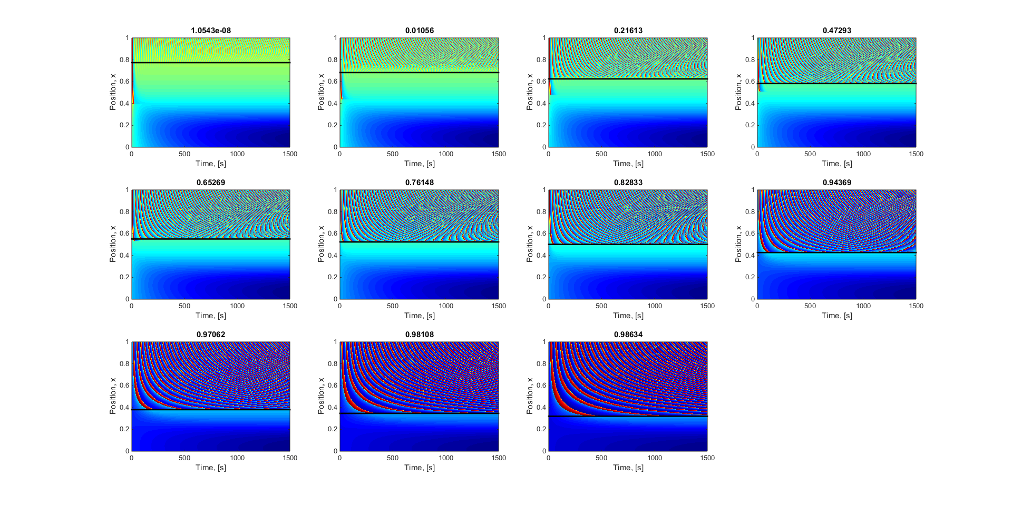

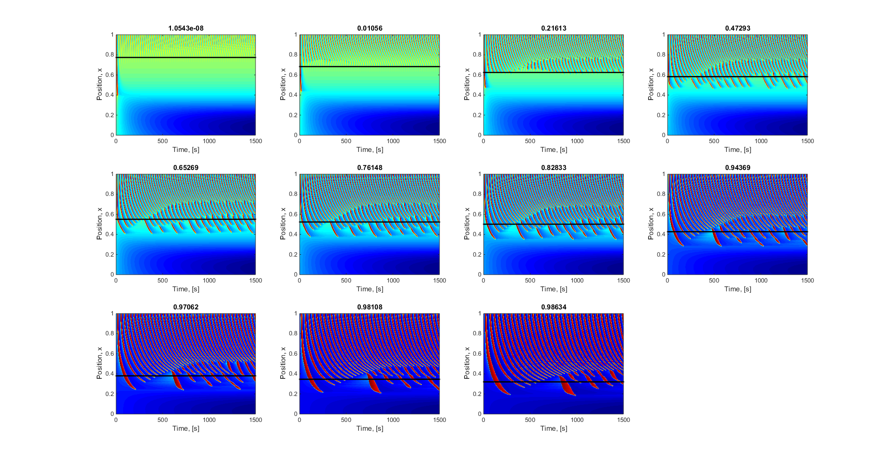

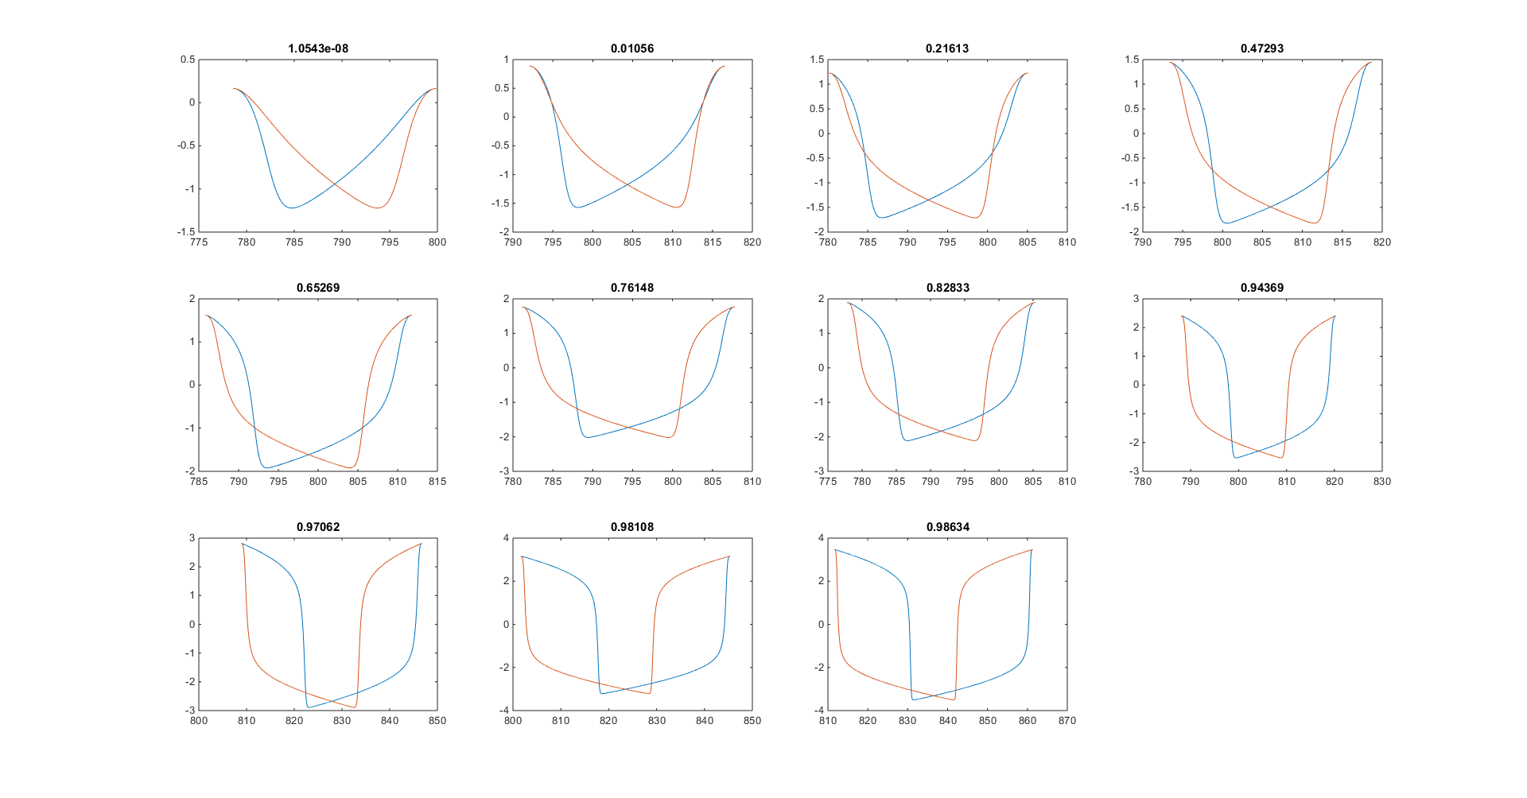

|  |  |  |  |  |  |  |
| --- | --- | --- | --- | --- | --- | --- |
| Xi | Front Heavy Clasifation | Index Bifurcation | Index Diffusion penetration | Bifurcation x | Diffusion penetration x | Difference |
| 0.400000000000000 | 1.05434774597014e-08 | 775 | 776 | 0.774000000000000 | 0.775000000000000 | -0.00100000000000000 |
| 0.500000000000000 | 0.0105602658997739 | 684 | 683 | 0.683000000000000 | 0.682000000000000 | 0.00100000000000011 |
| 0.600000000000000 | 0.216132052499295 | 626 | 608 | 0.625000000000000 | 0.607000000000000 | 0.0180000000000000 |
| 0.700000000000000 | 0.472933896986864 | 584 | 459 | 0.583000000000000 | 0.458000000000000 | 0.125000000000000 |
| 0.800000000000000 | 0.652693296427845 | 552 | 405 | 0.551000000000000 | 0.404000000000000 | 0.147000000000000 |
| 0.900000000000000 | 0.761478475700039 | 525 | 373 | 0.524000000000000 | 0.372000000000000 | 0.152000000000000 |
| 1 | 0.828330866917525 | 503 | 348 | 0.502000000000000 | 0.347000000000000 | 0.155000000000000 |
| 1.50000000000000 | 0.943691195549535 | 428 | 281 | 0.427000000000000 | 0.280000000000000 | 0.147000000000000 |
| 2 | 0.970622026337792 | 381 | 236 | 0.380000000000000 | 0.235000000000000 | 0.145000000000000 |
| 2.50000000000000 | 0.981081285788780 | 347 | 205 | 0.346000000000000 | 0.204000000000000 | 0.142000000000000 |
| 3 | 0.986336231535885 | 321 | 182 | 0.320000000000000 | 0.181000000000000 | 0.139000000000000 |

mybeta = 0.2*(1+tanh((x-0.5)/0.4))';

X_0 = -2; Y_0 = 2;

alpha = 0.2;

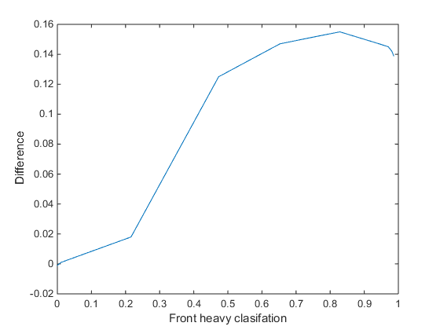

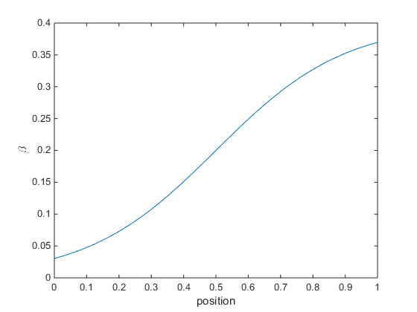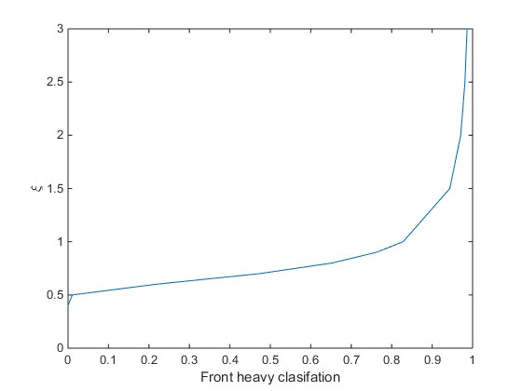

Run Two

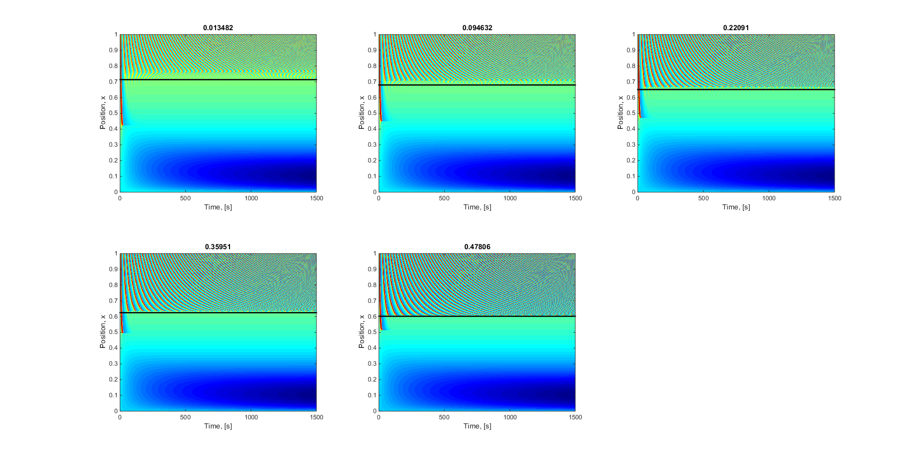

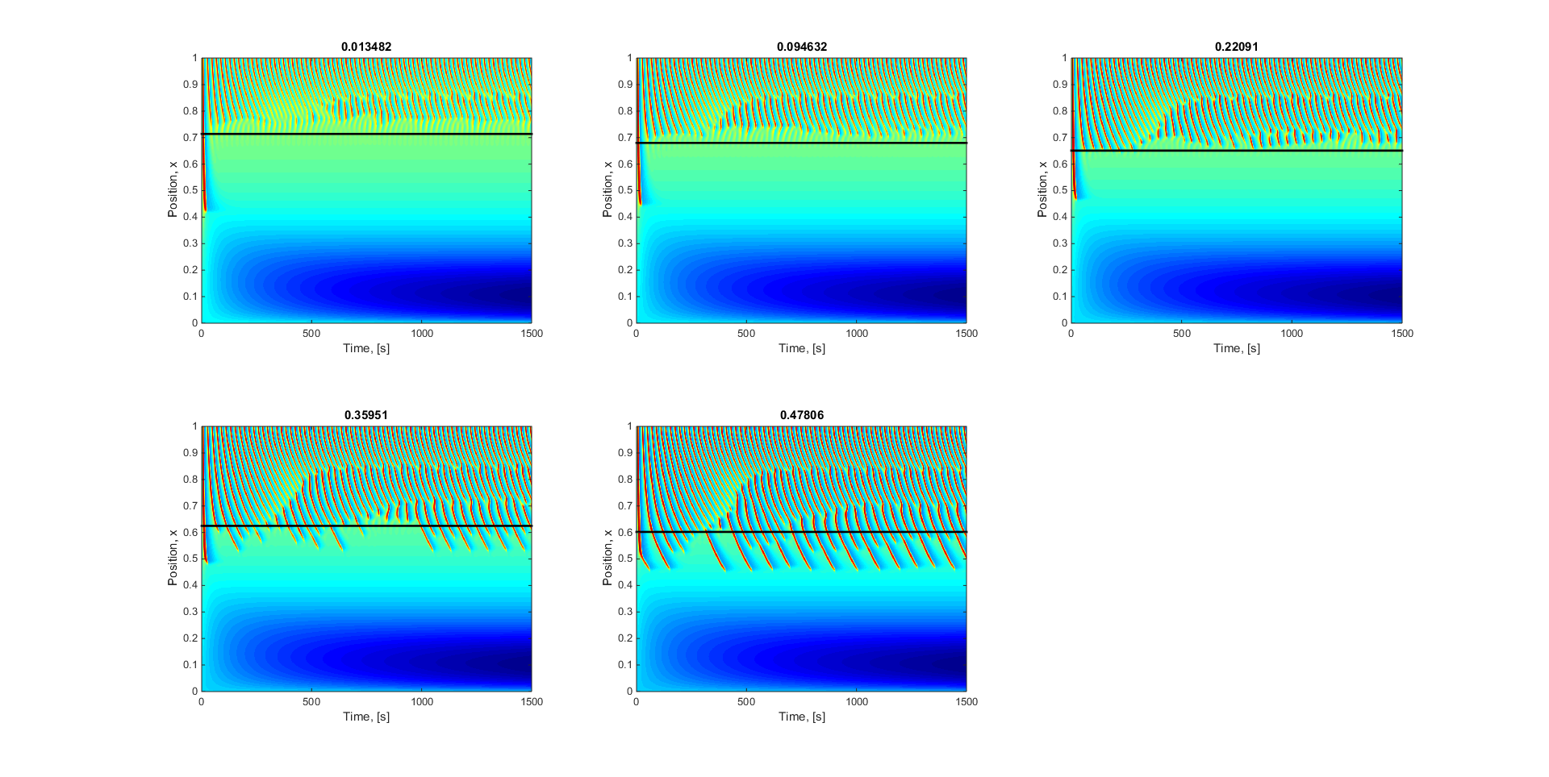

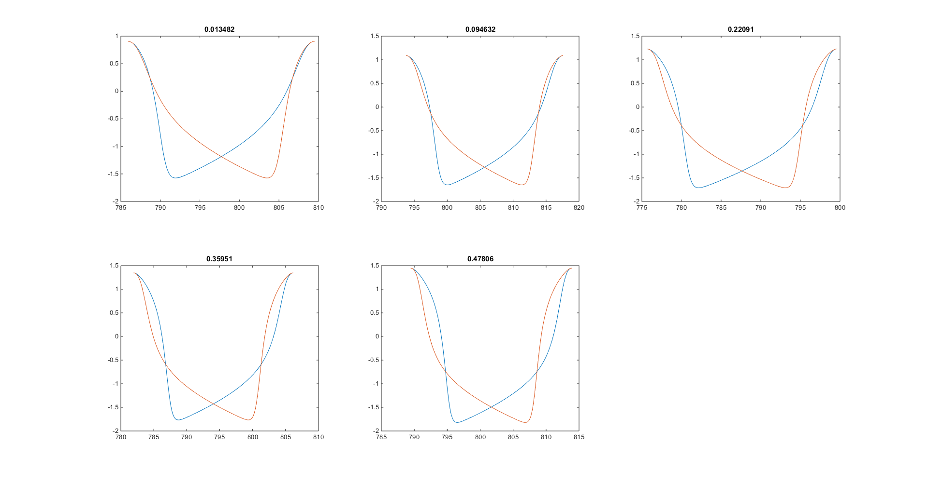

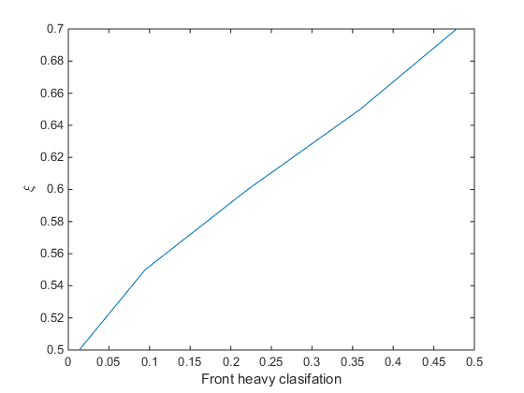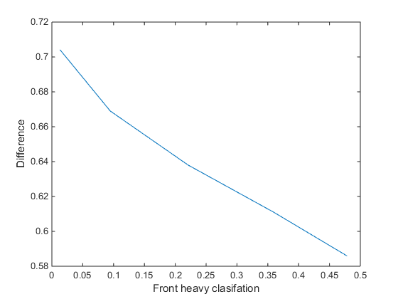

|  |  |  |  |  |  |  |
| --- | --- | --- | --- | --- | --- | --- |
| 0.500000000000000 | 0.0134820733265037 | 715 | 11 | 0.714000000000000 | 0.0100000000000000 | 0.704000000000000 |
| 0.550000000000000 | 0.0946315476574934 | 681 | 12 | 0.680000000000000 | 0.0110000000000000 | 0.669000000000000 |
| 0.600000000000000 | 0.220913229958866 | 652 | 14 | 0.651000000000000 | 0.0130000000000000 | 0.638000000000000 |
| 0.650000000000000 | 0.359511171104697 | 626 | 15 | 0.625000000000000 | 0.0140000000000000 | 0.611000000000000 |
| 0.700000000000000 | 0.478060755938372 | 603 | 17 | 0.602000000000000 | 0.0160000000000000 | 0.586000000000000 |

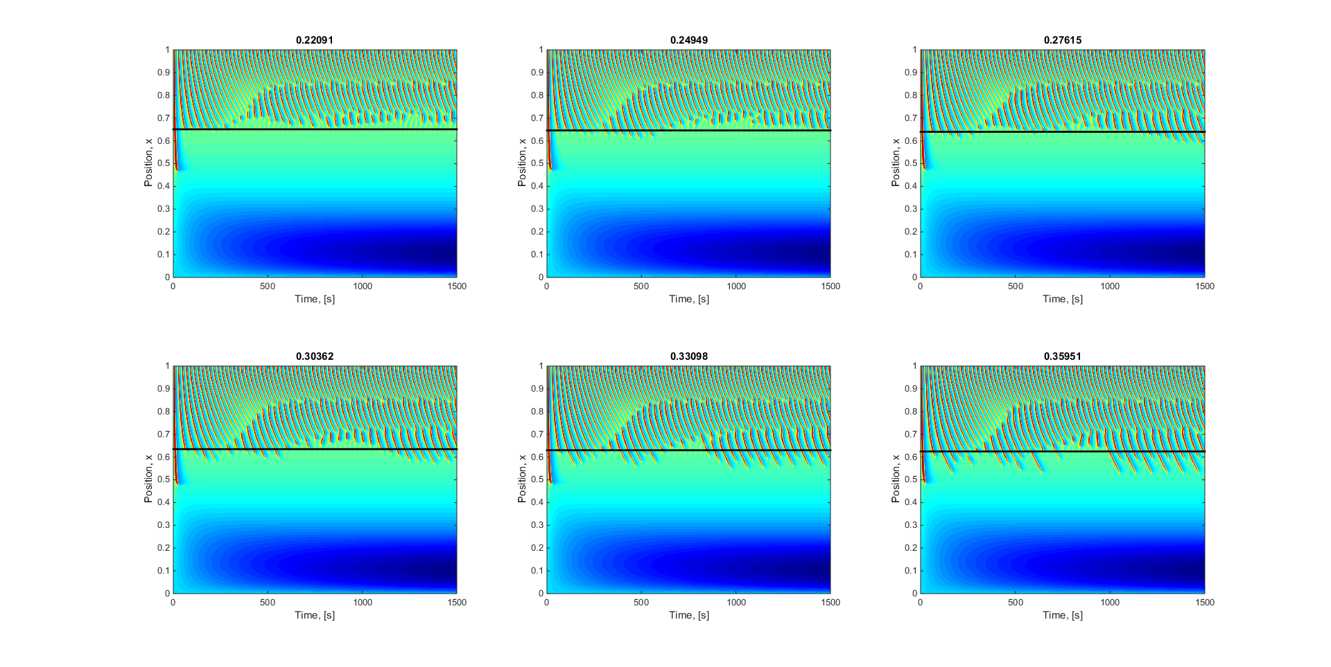

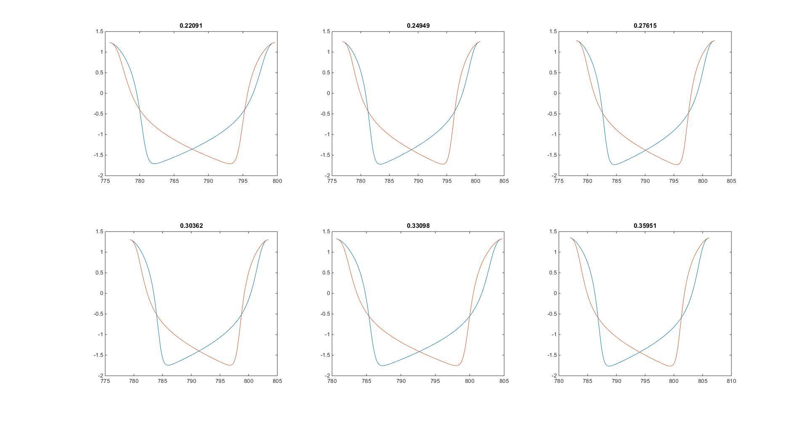

|  |  |  |  |  |  |  |
| --- | --- | --- | --- | --- | --- | --- |
| 0.600000000000000 | 0.220913229958866 | 652 | 14 | 0.651000000000000 | 0.0130000000000000 | 0.638000000000000 |
| 0.610000000000000 | 0.249491455807970 | 647 | 14 | 0.646000000000000 | 0.0130000000000000 | 0.633000000000000 |
| 0.620000000000000 | 0.276147477743647 | 641 | 14 | 0.640000000000000 | 0.0130000000000000 | 0.627000000000000 |
| 0.630000000000000 | 0.303617483408371 | 636 | 15 | 0.635000000000000 | 0.0140000000000000 | 0.621000000000000 |
| 0.640000000000000 | 0.330976679751267 | 631 | 15 | 0.630000000000000 | 0.0140000000000000 | 0.616000000000000 |
| 0.650000000000000 | 0.359511171103396 | 626 | 15 | 0.625000000000000 | 0.0140000000000000 | 0.611000000000000 |